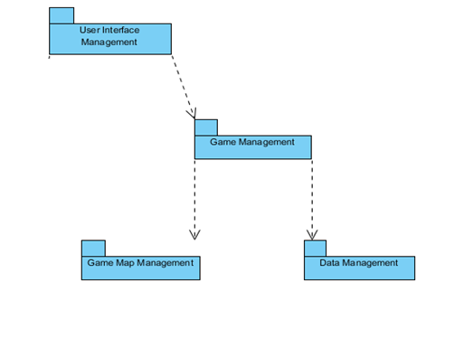
1. Introduction
In this phase of our project our main goal is to define our software objects and model both visually and textually how they collaborate to fulfill the requirements that were mentioned during our analysis. In this phase we will construct a conceptual solution to our game’s requirements, so that this report will play a key role in the implementation phase of our project.

  - Purpose of the system

System is a text based game and designed for entertaintment. In the game player has a character and by using command prompt player commands his character to perform actions like moving around, killing enemies, collecting items, inspecting surroundings etc. Aim of this game is exploring the world while keeping his character alive.

  - Design Goals

- Allow user to complete their task without being distracted by software or losing train of thought
- After user types commands system responses in less than one second
- Allow user to run the system on all types of operation systems
- Give users access to information they need to complete their task (i.e. information on other pages, etc.).
- Add clear tutorial about game to the help menu to make system easily understandable
- System will not interrupt the game play because of the small typos of the player
- System can be modified without changing entire structure of it

2. Software Architecture
We design our system in Model- View- Controller Architectural Style. It is the best convenient way for us.

2.1 Subsystem Decomposition
We decided to handle our games in 5 subsystems which connect themselves with the interactions shown in the figure. Details about subsystems and their classes are given in the subsystem services part.

2.2 Hardware / Software Mapping
In our project Java will be used as a programming language. Users who has enough tool to execute Java projects will be able to execute our program. Only software requirement for pur system is that.
When issue comes to hardware requirements, a regular keyboard is enough. Keyboard will be used to initialize the game, enter login information and commands to direct the game.
As a result, our project is not required an extra tool than that already exist in all computers.

2.3 Persistent Data Management
User information and save files will be saved as .DAT files to the harddrive. Interior of these files will be decided during implementation.
2.4 Access Control and Security
Upon creation of an account, login credentials of that account will be stored to the harddrive. When an user wants to play the game players must type in their login ID’s and passwords. If login is successfull their game data will be loaded and game will start. Otherwise they will get an error message explaining the situation. Users can access other players via a proxy and they only will be able to see their game condition and scores.

2.5 Boundary Conditions
Initializaton
Since Zoork does not have regular .exe or such extension, it will not require any installation. Game will be initialized via a .jar file.
Termination
Because of the neccessity of saving, game must be terminated with exit command otherwise system will not be able to save and store game data and will lose the process achieved since last save.
Error
In the case of the corruption of the data system will not be able to recover the data and all processes will be lost.

3.1. User Interface Management Subsystem
User Interface Management Subsystem includes a ConsoleView Class
ConsoleView Class
ConsoleView class is used to view all menus that can be reached by the main
menu of the game. This class is the first class that is initialized when user opens
the game. The UI that is created by this class includes a text based interface with following options “Play Game”, “Instructions”, “High Scores”, “Settings” and “Exit Game”. When “Play Game” option is choosed, further commands are asked from the used by providing a set of choices in a text based format. If “Instructions”, “High Scores” or “Settings” option is choosed, new text based interface is created by the class in order to show the information that is wanted by the user. ConsoleView class gets required information from GameSystem class. Last choice on the menu, “Exit Game”, if any progress made it saves it and finally exits the game.
3.3. Game Management Subsystem
Game Management Subsystem includes following classes.
GameSystem Class
GameSystem manages all aspects of the game. GameSystem supplies
information to UI-related classes with the information it gets from the classes of the
Attribute Management Subsystem and Data Management Subsystem, and controls the progress of the game and updates the game during game-play. Decision of whether the game is over or not is also made by this class.

Game Class
After user starts to play the game, game class becomes the messanger of the system. It helps to the objects to reach t othe classes in other subystems. For example object of the Reader class can call methods of the player object with the instance of Game object which is a property of Reader class(game.getPlayer().go(Direction.d) will be called from Reader according to Input)

Character Class
Character class is an abstract class which is expanded by Player class and NonPlayerCharacter class

NonPlayerCharacter class
NonPlayerCharacter class is an expanded by HostileCharacter class. It exist to make it possible to make friendly NPC's later on
HostileCharacter Class
Instances of HostileCharacter class tends to attack to player

Player Class
Player class is where all player stats and action methods exist.

3.4. Game Map Management Subsystem
Game Map Management Subsystem includes 3 classes which are Map, Location and LocationFactory class.

Map Class
Map class keeps a 2 dimensional Location array and if player hits the bounds it will extend it from every side. It has a LocationFactory which will generate locations the player moves.

Location Class
Location class keeps a list of Things as a property, which will be randomly generated by LocationFactory.
LocationFactory Class
LocationFactory class keeps a queue of Locations, and it will feed the map with those when player moves to an unvisited location. It will also generate new maps when idle to keep the queue non-empty.
3.6. User Management Subsystem
User Management Subsystem includes following classes.
UserManager Class
It handles User Login and data save operations

User Class
Object of this class is initialized when user login, it will carry information about user and this data will be saved before exitting

3.7. Map Objects Subsystem
Map Objects Subsystem includes following classes.
Direction Enumeration
It carries direction information. Used in many direction based methods across the system.

Thing Interface
An Interface that implemented by Item and Furniture Classes
Furniture Class
Furnitures that exists in locations, player cant take those but may interact with it

Item Class
Items that exist in locations, and inventories of characters. Can be taken and used accordingly by player. This includes weaponry and foods.
3.7. IO Subsystem
Reader Class
Reads and analyzes the typed user input, and calls player methods accordingly.

4.1 Object Design Trade-Offs

This section defines the different tradeoffs in object design and the need to make decisions about them. In the making of a text-based computer game, aspects such as memory usage, availability, durability and maintainability are important. Compromises need to be made from these in order to come up with the optimal design.
- Memory space vs. response time

Text-based games often need a good share of memory even though no graphics are involved. As more memory is required to store all the user’s data, response time may deteriorate; this, however, should not happen. The management classes involved in sending and receiving data, in turn, take care of this problem by limiting data transfer to only when it is required.

- Buy vs. build

Usually, a build policy may be sought because of the simple design of most objects. The parser component, however, may be supplied from elsewhere, which will in fact save time. The compromises needed to be made here is between cost and time, and one component may be bought if the cost is not too high, and if it will save time.

- Platform dependence vs. flexibility

The game needs an optimal platform, such as the operating system and even architecture. This optimal platform will allow perfect programmability for the game, but it also needs to be flexible, such that only subtle changes to the design will grant it new platform dependency properties. Most games in the market are optimized for one platform, however since this is a text-based game, the switch between platforms is as simple as an integrated pattern.

- Design patterns
Several design patterns have also been compared in terms of tradeoffs. The Bridge pattern was seen to provide more flexibility in terms of modifying existing code. Examples of this pattern can be seen in the figure provided in the following page. Since a general algorithm was not required for the game, a strategy pattern was not considered. In fact, several design patterns were used in different subsystems. These subsystems and the design patterns will be discussed in the upcoming section.

4.2 Final Object Design

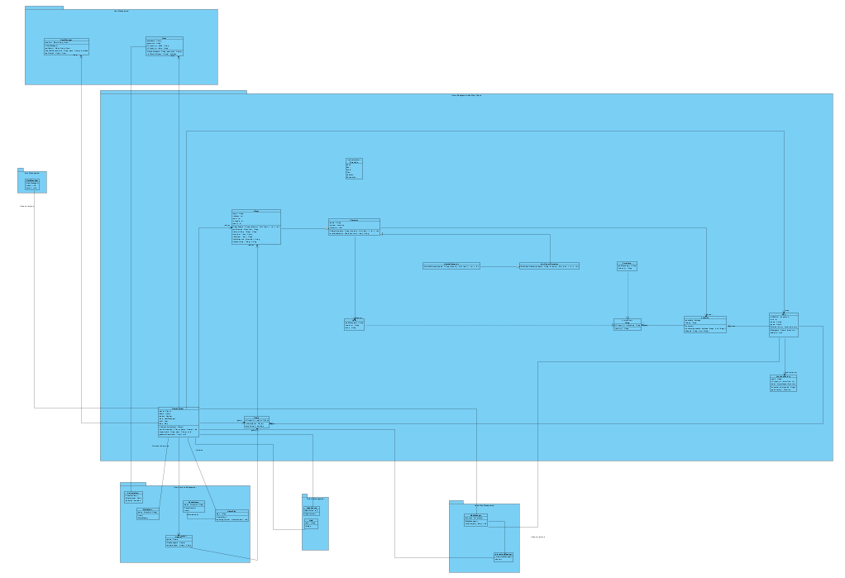
As the final object design is too large to make every component legible, the document will display the object design as composed of its subsystems.

Figure shows object diagram
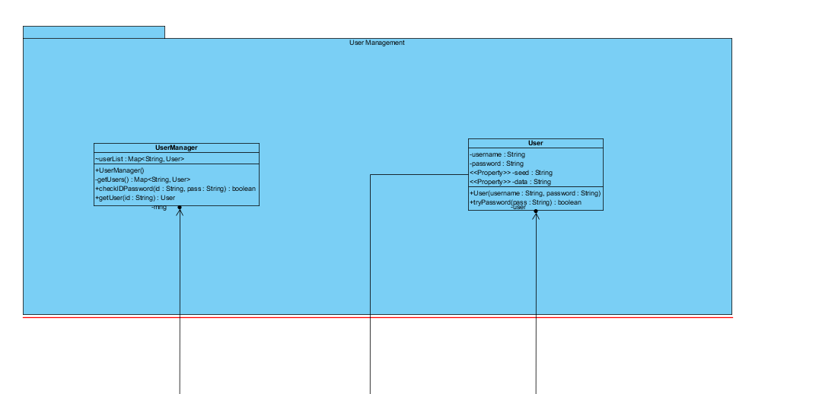

Figure shows User Management Subsystem

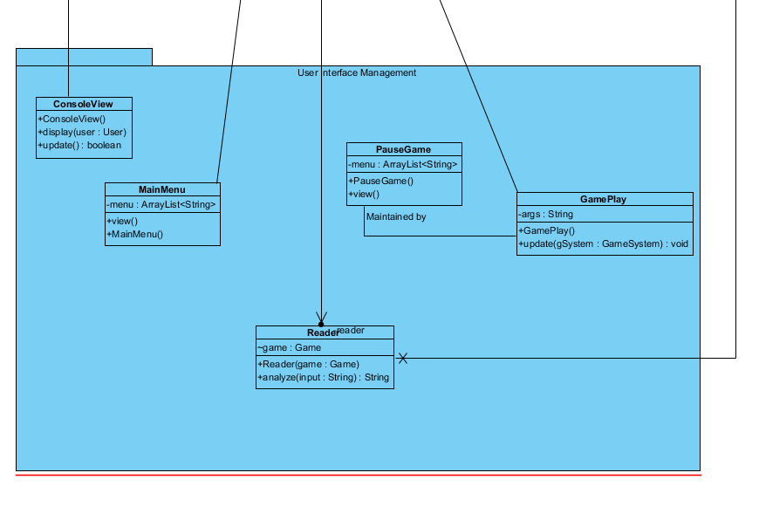

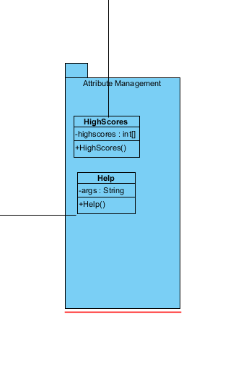
Figure shows UI Management Subsystem

Figure shows Attribute Management
Subsystem
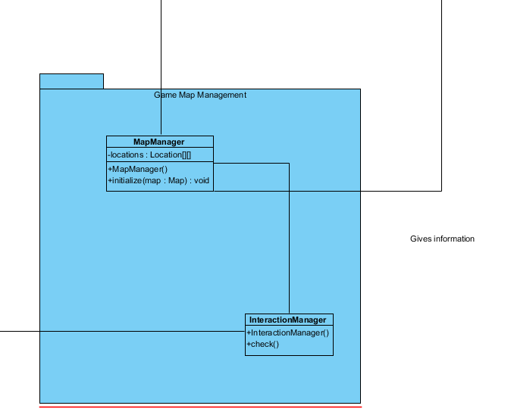
Figure shows Game Map Management Subsystem

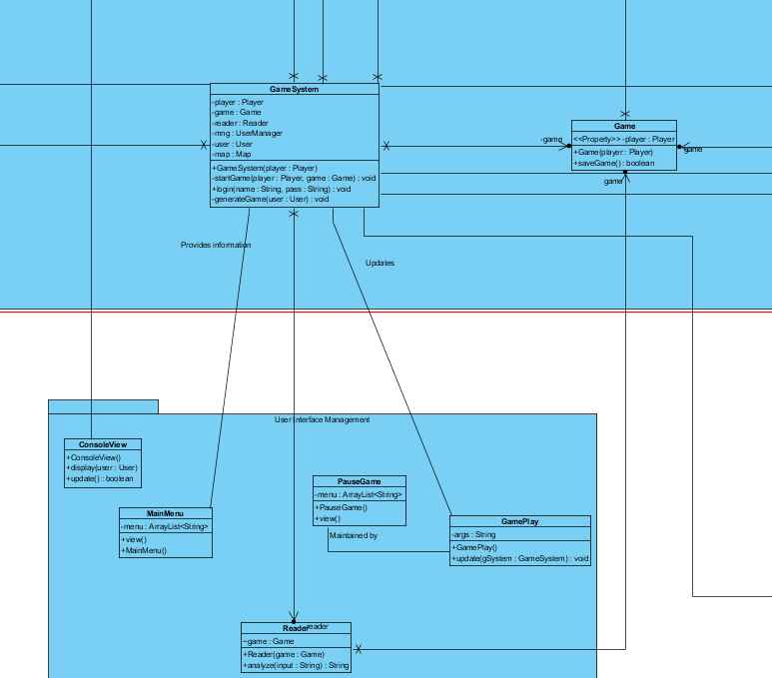

Figure shows Game Management Subsystem and its relations with UI Management Subsystem

At this point one can see that the Bridge pattern has been used; new code may be written for classes in the UI Management subsystem flexibly. Also, note that delegation has been used before inheritance.

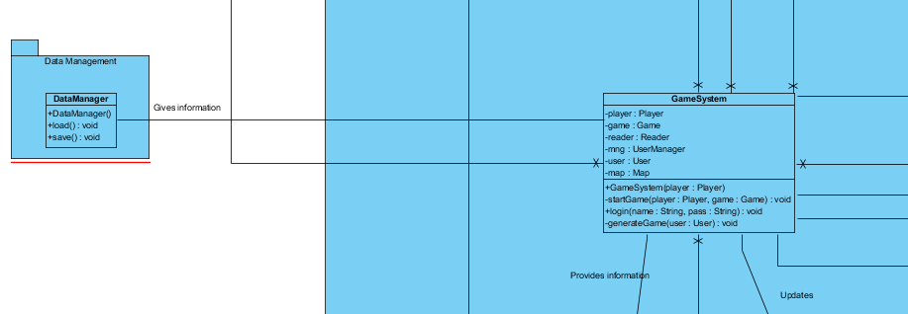

Figure shows the interactions of the Data Manager subsystem with class GameSystem
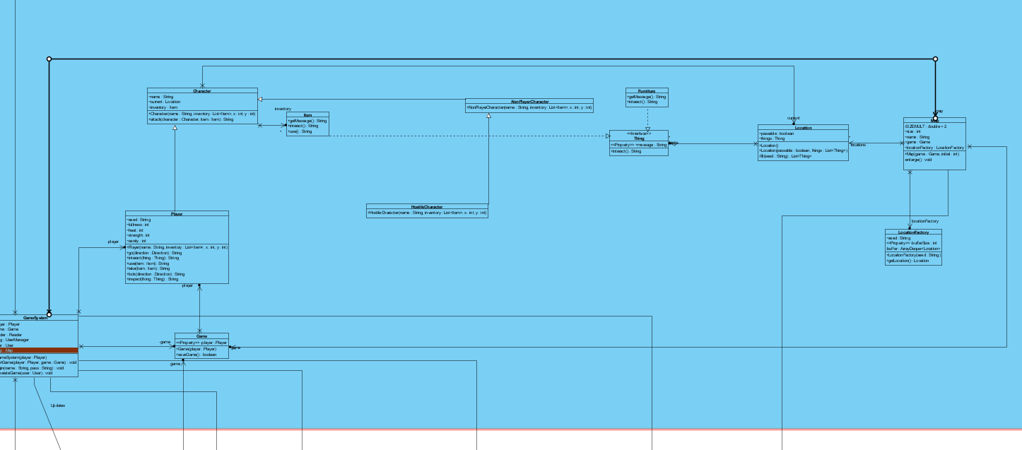

Figure shows the remaining objects and their interactions with GameSystem.
This part of the design was done choosing Abstract Factory design, hence the multiple inheritance relationships. The GameSystem class provides methods to classes like Map and Player. This design was superior to others in the sense that it allows compatibility; there is a single solution for implementing the methods of these classes. It also allows quick modifications.

4.3.Packages
We divided the project into packages according to its subsystems
a)game Package
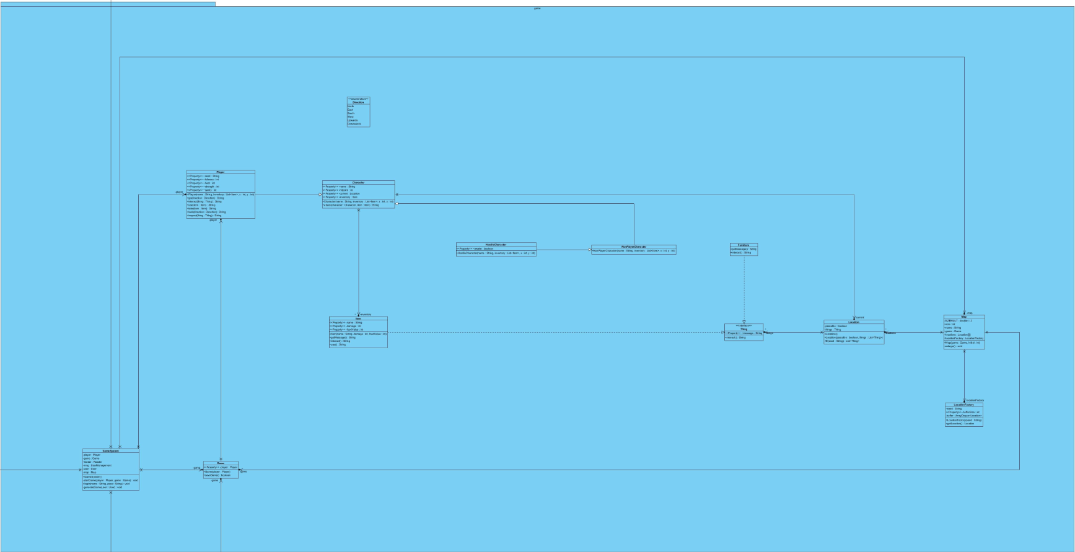
This package consists of game elements such as player,item, Map. This package itself does not have any connections to outside of the program. It just handles tasks like, map generation, actions and it defines objects like player, hostile characters, items.
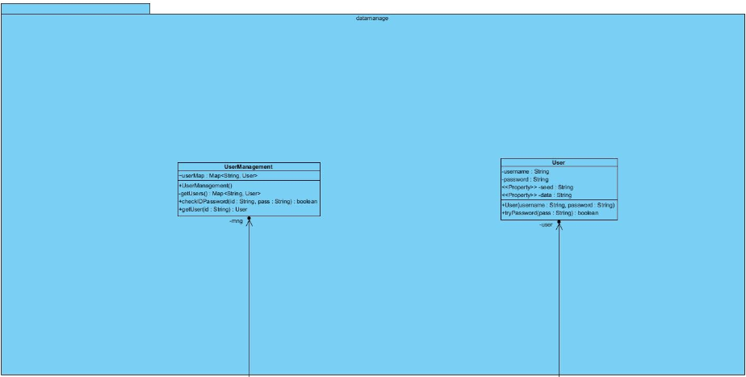
b)datamanage Package
This package handles tasks like reading files, user authentication, saving and loading games.
c)IOmanage Package
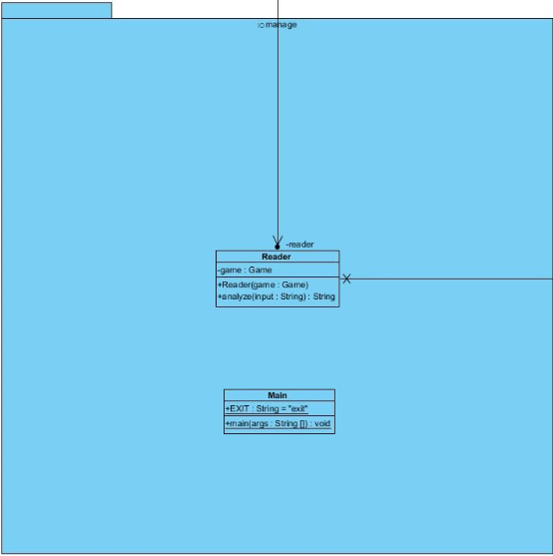
This package manages reading and understanding of the user inputs and calls Methods from game Package according to this inputs
4.4.Class Interfaces
a)game Package

1.public abstract class Character

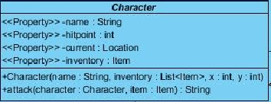
Properties

private String name:
This is name of the Character
This property is private because it is only intended to access by setter and getter Methods provided

private Location current:
This is the current location of the Character
This property is private because it is only intended to access by setter and getter Methods provided

private List<Item> items:
This is the list of items that character has
This property is private because it is only intended to access by setter and getter Methods provided

private int hitpoint:
Remaining hit-points of the Character
This property is private because it is only intended to access by setter and getter Methods provided

Constructors

public Character( String name,List<Item> inventory,int x,int y);
@param name String name to assign to character
@param inventory List of Items Character has
@param x Location of the Character
@param y Location of the Character
name and inventory will be initialized. current Location of the Character will be set according to x and y
Methods
public String attack(Character target,Item item);
Player attacks given target with the given item if it is possible, result given with an appropriate String message Damage will be calculated according to users stats, and equipment This method designed to be called from Player object inside Game object inside Parser object game.player.attack(character,item);
@param target to Attack
@param Item to use while attacking
public String getName();
Getter method for the property name
@return name as a String
public Location getLocation();
Getter method for the property Location
@return current Location of the Character
public List<Item> getItems()
Getter method for the property items
@return items as a List<Item> object
public int getHitPoints()
Getter method for the property hitpoint
@return hitpoint Integer
2.public abstract class NonPlayerCharacter extends Character
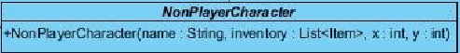
Constructors
public NonPlayerCharacter( String name,List<Item> inventory,int x,int y);
@param name String name to assign to character
@param inventory List of Items Character has
@param x Location of the Character
@param y Location of the Character
This will call the super Constructor with the given parameters

3.public class HostileCharacter extends NonPlayerCharacter
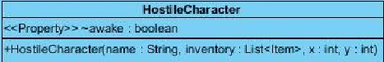
Properties
private boolean awake:
this boolean shows that hostile character is aware of the presence of the player, and it will attack to player with the each action player does.
This property is private because it is only intended to access by setter and getter Methods provided
Constructors
public NonPlayerCharacter( String name,List<Item> inventory,int x,int y);
@param name String name to assign to character
@param inventory List of Items Character has
@param x Location of the Character
@param y Location of the Character
This will call the super Constructor with the given parametersMethods
Methods
public boolean getAwake()
Getter method for the property awake
@return awake as a boolean
public void setAwake(boolean newAwake)
Setter method for the property awake
sets the awake boolean accordingly

4.public class Player extends Character
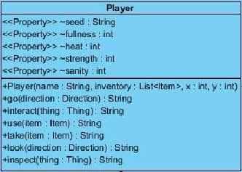
Properties

private String seed:
This is the seed of the Player, all randomness will be according to this value, this way players will be able to challenge other players on same generation, also they will be able to play to play on the same world again
This property is private because it is only intended to access by setter and getter Methods provided
private int fullness:
This is the hunger level of the Player, it is designed as fullness to make it parallel with other stats, this number will decrease with every action player does, when it hits zero player will starve
This property is private because it is only intended to access by setter and getter Methods provided

private int heat:
This is the heat level of the player, this will change according to surrounding temperature. Player is forced to find some heat source in order to survive nights
This property is private because it is only intended to access by setter and getter Methods provided

private int strength:
This is the strength stat of the player, this number will act as a multiplier when calculating the damage output of his/her atacks. Player's strength may increase according to tasks done, or decrease with hunger, etc.
This property is private because it is only intended to access by setter and getter Methods provided

private int sanity:
This is the sanity level of the player, It will decrease in dark (night,dungeons,etc.) and will increase if player has no hunger, heat problem during daytime. If this number goes too low, game will be over
This property is private because it is only intended to access by setter and getter Methods provided

Constructors

public Player(String name, List<Item> inventory, int x, int y);
@param name String name to assign to Player
@param inventory List of Items Player has
@param x Location of the Player
@param y Location of the Player
This will call the super Constructor with the given parameters
Methods
public String go(Direction direction);
@param direction to move
@return resulting String message
Player moves according to given direction if it is possible

public String interact(Thing thing);
@param thing to interact
@return resulting String message
Player interacts with given Thing if it is possible
public String use(Item item);
@param item to use
@return resulting String message
Player uses given Item if it is possible
public String take(Item item);
@param item to take
@return resulting String message
Player takes given Item if it is possible, if successful Item will be added to players inventory.
public String look(Direction direction);
@param direction to look
@return resulting String message
Player looks to given direction if it is possible
public String inspect(Thing thing);
@param thing to inspect
@return resulting String message
Player inspects given thing if it is possible,Reader will understand look Thing, as inspect Thing
public String getSeed();
@return seed as String
Getter method for the property seed
public void setFullness(int fullness);
@param fullness to set
Setter method for the property fullness
public int getFullness();
@return fullness as int
Getter method for the property fullness

public void setHeat(int heat);
@param heat to set
Setter method for the property heat
public int getHeat();
@return heat as int
Getter method for the property heat

public void setStrength(int strength);
@param strength to set
Setter method for the property strength
public int getStrength();
@return strength as int
Getter method for the property strength

public void setSanity(int sanity);
@param sanity to set
Setter method for the property sanity
public int getSanity();
@return sanity as int
Getter method for the property sanity

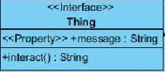
5.public interface Thing
Methods
public String getMessage();
@return String message to be displayed
This Methods returns the message to be send when interacted with the object itself

public String interact();
@return String message to be displayed
A method to interact with the Thing

6.public class Furniture implements Thing
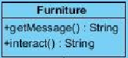
Methods
public String getMessage();
@return String message to be displayed
This Methods returns the message to be send when interacted with the object itself
Methods
public String interact();
@return String message to be displayed
A method to interact with the Furniture

7.public class Item implements Thing
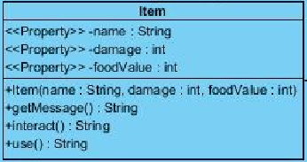
Properties
private String name:
This is name of the Item
This property is private because it is only intended to access by setter and getter Methods provided

private int damage:
If Item is a weapon this will get a positive value and it will be used to calculate output damage of the Character attacks. If it is zero this means it is not a weapon
This property is private because it is only intended to access by setter and getter Methods provided
private int foodValue:
If Item is a food this will get a positive value and it will be edible and this food will increase the fullness of the Player by the value of it
This property is private because it is only intended to access by setter and getter Methods provided
Constructors
public Item( String name,int damage,int foodValue);

Methods
public String getMessage();
@return String message to be displayed
This Methods returns the message to be send when interacted with the object itself
Methods
public String interact();
@return String message to be displayed
A method to interact with the Furniture
public String use()
@return String message to be displayed
This method is called when Item is used
public String getName();
@return name as String
Getter method for the property name

public int getDamage();
@return damage as int
Getter method for the property damage

public int getFoodValue();
@return foodValue as int
Getter method for the property foodValue

7.public class Location
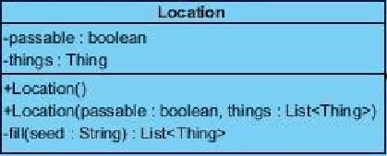
Parameters
private boolean passable;
Indicates if Location is passable, can be changed as Boolean[3] passable,
to indicate directions from this location depending of the implementation
This property is private because it is only intended to access by setter and getter Methods provided
private List<Thing> things;
List of Thing's inside this location, will be randomly generated if location is new, while loading it will be generated according to given List
This property is private because it is only intended to access by setter and getter Methods provided
Constructors
public Location();
This is the default Constructor which is used to generate new locations randomly
public Location( boolean passable,List<Thing> things);
@param passable boolean that designates if location is passable
@param things is a list of Thing objects which exist on that location object
This Constructor is used when loading a saved game from a save file

Methods

private List<Thing> fill(String seed);
@param seed a string that manages the randomness
@return list of Thing's that exists on that location

This method randomly fills a location according to a seed. This private method called when object is constructed with default Constructor.

8.public class LocationFactory
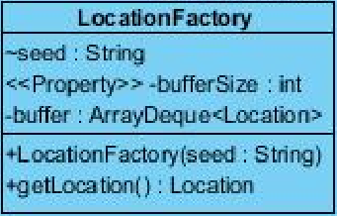

private String seed;
A copy of the seed of the player to manage randomness
This property is private because it is only intended to access by setter and getter Methods provided
private int bufferSize;
A designated buffer size of buffer to manage the number of Locations to keep in the ArrayDeque
This property is private because it is only intended to access by setter and getter Methods provided
private ArrayDeque<Location> buffer;
An ArrayDeque that keeps generated Locations inside. It is used as a queue in this program
This property is private because it is only intended to access by setter and getter Methods provided

Constructors
public LocationFactory(String seed);
@param seed as a String to manage randomness
This will initialize the property seed with parameter seed
public void setBufferSize(int bufferSize);
@param bufferSize as a String to change buffer size according to needs
public Location getLocation();
@return newLocation
This method poll a Location from arraydeque and return it.
public void addLocation();
This method will be called when system is idle and it will fill the arraydeque with newly generated Locations

8.public class Map
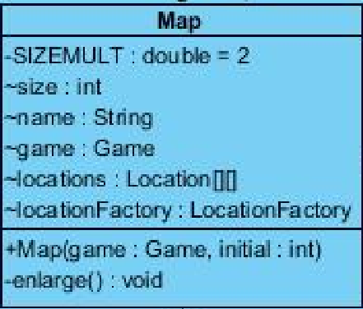
Parameters
private final double SIZEMULT = 2;
SIZEMULT is a private constant double that designates the size increase of the map when border is reached
private int size;
size is an int that shows the current size of the square map
private String name;
This property is private because it is only intended to access by setter and getter Methods provided
Game game;
An instance of the game object to reach other objects in the program

private Location[][] locations;
A 2 dimensional array of Locations to represent the Map.
This property is private because it is only intended to access by setter and getter Methods provided
private LocationFactory locationFactory;
A LocationFactory to generate Locations when player move

Constructors
public Map(Game game,int initial);
@param game, game object passed from the caller to make it possible to reach other objects In the program
@param initial an integer value that shows the initial size of the square 2 dimensional Location array
Constructor sets the Properties with the parameters and initializes locations and LocationFactory
Methods
private void enlarge();
This method is called when player hits the borders of the existing Map, it will create a new Location[][] with the size = (size *SIZEMULT) and pass the existing locations to the middle of the new Location[][]

9.public enum Direction
Direction is enumeration that shows directions with the following constants in it
North,
East,
South,
West,
Upwards,
Downwards
10.public class Game
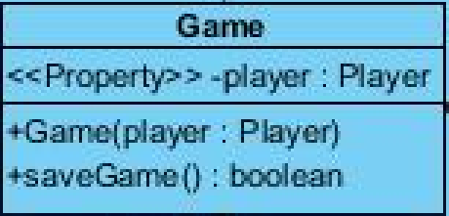
Parameters
private Player player;
An Instance of the player objects to be called from other classes that have the instance of the game object
for example game.getPlayer().go(Direction.North)
This property is private because it is only intended to access by setter and getter Methods provided

Constructors
public Game( Player player);
@param player is an instance of player from caller object
Constructor sets property player with parameter player

Methods

public Player getPlayer();
@return Player
returns the player object
11.public class GameSystem
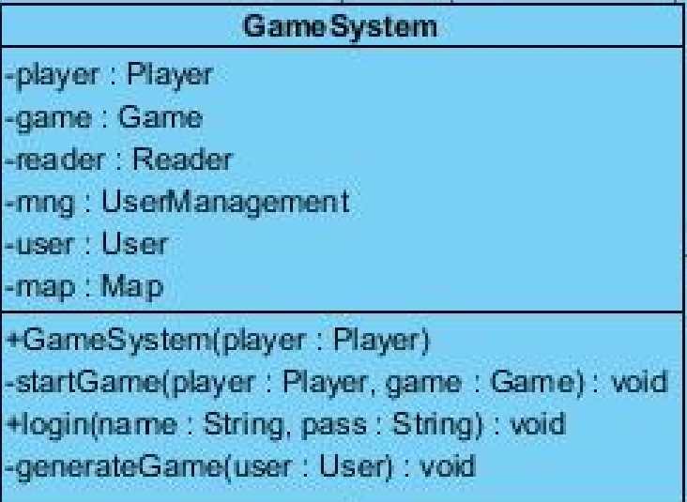
Properties
private Player player;
A player object that will be generated according to User logged in
This property is private because it is only intended to access by setter and getter Methods provided
private Game game;
A Game object that will be generated according to User logged in
This property is private because it is only intended to access by setter and getter Methods provided
private Reader reader;
A Reader object which will analyze the inputs of the User and call the Methods of the player object
This property is private because it is only intended to access by setter and getter Methods provided
private UserManagement mng;
An Object that manages the login authentications
This property is private because it is only intended to access by setter and getter Methods provided
private User user;
An object that represents the user logged in and keeps its data at runtime and saves it during logout
This property is private because it is only intended to access by setter and getter Methods provided
private Map map;
A Map object which player will be wandering during playtime
This property is private because it is only intended to access by setter and getter Methods provided
Constructors
public GameSystem();
A Constructor with no parameters will initialize the UserManagement object

Methods
private void startGame(Player player,Game game);
@param player a Player object that generated according to user data
@param game, a Game object that generated according to user data
A private method that will be called when user logs in and starts the game
public void login(String name, String pass);
@param name is a String that shows the login name of the user
@param pass is a String that shows the login password of the user
This method will take username and password and call the authentication method of the UserManagement object. If authentication is successful it will call the generateGame method.
private void generateGame(User user);
@param user the user object that authenticated
This method will load the game according to User data, if data is empty it will randomly assign a seed and generate according to that value. After loading it will start the game.
b)datamanage Package
1.public class User
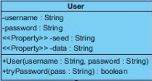
Properties
private String username;
A String that indicates the login username of the User
This property is private because it is only intended to access by setter and getter Methods provided
private String password;
A String that indicates the login password of the User. This can be encrypted in order to increase security
This property is private because it is only intended to access by setter and getter Methods provided
private String seed;
A String, seed value that will guide randomness
This property is private because it is only intended to access by setter and getter Methods provided
private String data;
A String, data which will be loaded at the startup, and will be saved during exit
This property is private because it is only intended to access by setter and getter Methods provided

Constructors
public User(String username, String password);
@param username,that indicates the login username of the User
@param password,that indicates the login password of the User
This Constructor sets the parameter values to property values

Methods
public String getSeed();
@return seed as a String
This is the getter Method for Property seed
public String getData();
@ return data as a String
This is getter Method for Property data
public boolean tryPassword(String pass)
@param pass a String that will be compared to password of the user
@return boolean success of the trial
This method checks if password user entered is correct

2.public class UserManagement
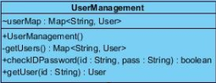
private Map<String,User> userMap;
public UserManagement();
This Constructor takes no parameters and it fills userMap with the method getUsers()
private Map<String,User> getUsers();
@return Map<String,User> as a map of Users with names as their keys
This method reads a certain data file and fills the userMap accordingly
public boolean checkIDPassword(String id,String pass);
@param id a String that shows the id that will be tried
@param pass a String that shows the password that will be tried
@return boolean success
This method finds the user with given id and checks if pass is correct, and returns a boolean that shows the success of the authentication
public User getUser( String id);
@param id a String as the id of the User
@return User that found,null if User does not exists
This method looks for given id in the userMap and returns that user if it exists
c)IOManage package
1.public class Reader
Properties
private Game game;
A game object that will help Reader to reach other objects in the program
Constructors
public Reader(Game game)
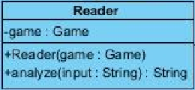
@param game a simple Constructor to set property game as parameter game
Methods
public String analyze( String input)
@param input a string input that typed by the user
@return resulting String message to print on the screen
This Method takes a String input with format action receiver tool or action direction, etc. and execute the regarding Methods. After execution returns the resulting String to the caller

5.1.Glossary
zOOrk : Text based game, that implemented by Java an an OO project.
5.2.References
http://en.wikipedia.org/wiki/Zork
fatih.ug.bilkent.edu.tr – Project API documentation

